77255599

Agreement url:   
  
  
https://jpad.com.pk/index.php/jpad/issue/archive

Publication year, Month, volume, issue

Current Issue

Page Range

English title

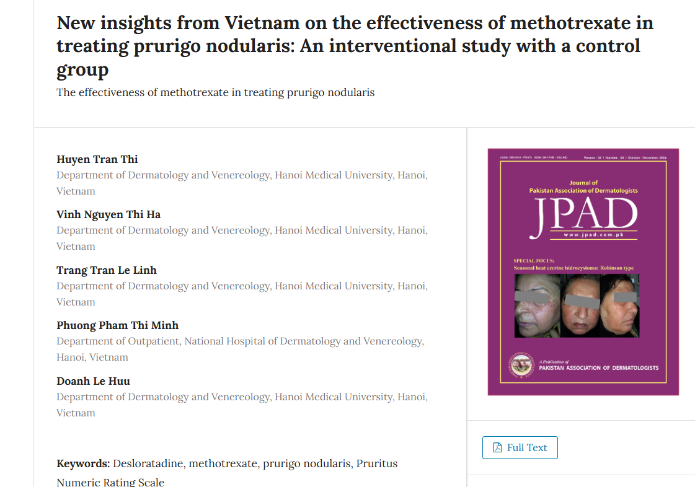

Download the pdf